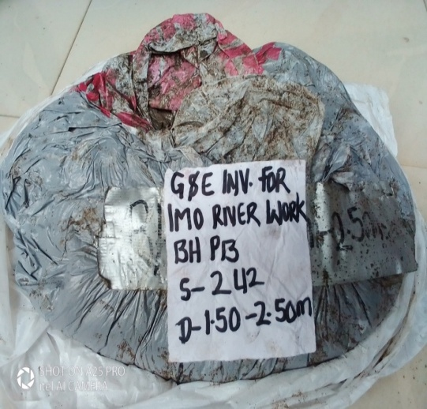 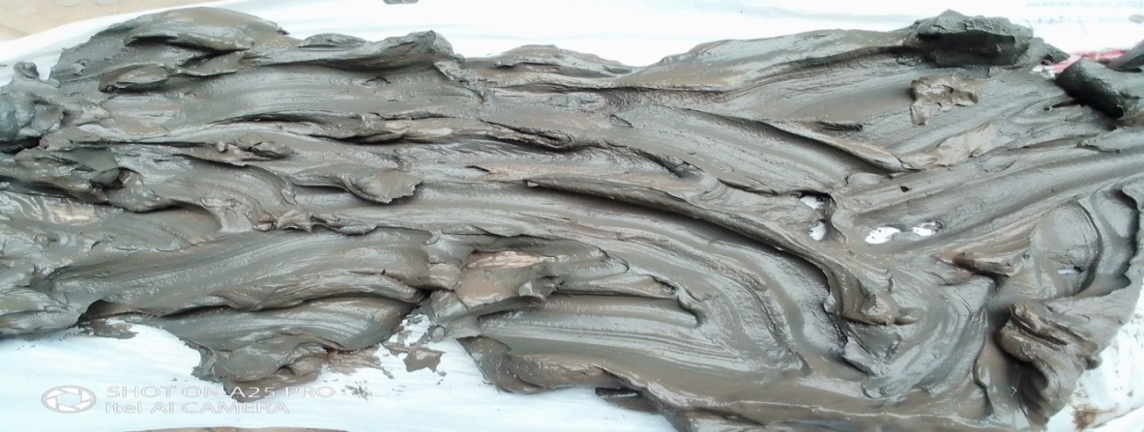

Plate 1: Clay sample in sealed bad and under atmospheric drying

Table 1: Tabulation of results for the sieve analysis of the sand sample

|  |  |  |  |  |  |
| --- | --- | --- | --- | --- | --- |
| Sieve | Sieve size  (mm) | Mass retained (kg) | % mass retained | Cumulative mass retained | % cumulative passing |
| L1 | 4 | 0.091 | 1.626 | 1.626 | 98.373 |
| L2 | 2.5 | 0.045 | 0.813 | 2.439 | 99.56 |
| L3 | 1.8 | 0.908 | 16.26 | 18.699 | 81.3 |
| L4 | 1 | 4.313 | 77.23 | 95.934 | 4.065 |
| L5 | 0.8 | 0.227 | 4.065 | 100 | 0 |

Table 2: Tabulation of results from the flow experiment on the control sample

|  |  |  |  |
| --- | --- | --- | --- |
| Parameter | Value (unit) | Parameter | Value (unit) |
| Length | 8 (cm) | Dry weight | 0.13215 (kg) |
| Diameter | 3.1 (cm) | Wet weight | 0.13653 (kg) |
| Cross-sectional area | 7.548 (cm2) | Inlet pressure | 0.8 (Bar) |
| Sample volume | 60.389 (cm3) | Outlet pressure | 0.5 (Bar) |
| Grain size | 1.15 (mm) | Volume collected | 305 (mL) |
| Porosity | 0.07 (-) | Time run | 60 (sec) |
| Permeability | 22.411 (mD) | Viscosity of liquid | 1.04 (cp) |

Table 3: Data collection for the synthetic samples

|  |  |  |  |  |  |  |  |
| --- | --- | --- | --- | --- | --- | --- | --- |
| Sample | h (cm) | W (cm) | B (cm) | Shape | Volume (cc) | Mass (kg) | Mass wet (kg) |
| S1 | 8 | 16 | 16 | box | 2048 | 4.25 | 4.4 |
| S2 | 9.5 | 21.1 | 12.4 | box | 2485.58 | 5.19 | 5.31 |
| S3 | 4.8 | 16.78 | 11.85 | box | 954.4464 | 1.72 | 1.82 |
| S4 | 6.5 | 12.2 | 12.2 | box | 967.46 | 1.77 | 1.75 |
| S5 | 6.4 | 13.3 | 13.3 | box | 1132.096 | 2.05 | 2.15 |
| S6 | 7 | 16.2 | 10.7 | box | 1213.38 | 2.3 | 2.39 |
| S7 | 10.7 | 9.2 | 9.2 | cylinder | 711.3865 | 1.62 | 1.65 |
| S8 | 7.5 | 11 | 10.5 | box | 866.25 | 1.76 | 1.8 |
| S9 | 4.75 | 15.8 | 11.2 | box | 840.56 | 1.56 | 1.6 |
| S10 | 7.6 | 9.2 | 9.2 | cylinder | 505.2839 | 1.15 | 1.16 |

Table 4: The required properties of the sample for the HF simulator run

|  |  |  |  |  |  |
| --- | --- | --- | --- | --- | --- |
| Sample | Aspect ratio | Bulk density (kg/m3) | Porosity (-) | Permeability (mD) | E (MPa) |
| S1 | 0.5 | 2075.195 | 0.0732 | 21.142 | 4130.554 |
| S2 | 0.450 | 2088.044 | 0.0482 | 5.742 | 8064.675 |
| S3 | 0.286 | 1802.092 | 0.0314 | 1.529 | 16061.85 |
| S4 | 0.533 | 1829.533 | 0.0516 | 7.093 | 7229.286 |
| S5 | 0.4812 | 1810.8 | 0.0883 | 38.323 | 3057.774 |
| S6 | 0.432 | 1895.531 | 0.0741 | 22.002 | 4047.66 |
| S7 | 1.163 | 2277.243 | 0.0421 | 3.778 | 10020.31 |
| S8 | 0.681 | 2031.746 | 0.0461 | 5.001 | 8662.214 |
| S9 | 0.300 | 1855.906 | 0.0475 | 5.490 | 8253.533 |
| S10 | 0.826 | 2275.948 | 0.0197 | 0.373 | 33753.29 |

Figure 1- Run 1 to 4 of data generation for the objective function

Figure 2- Run 5 to 8 of data generation for the objective function

Figure 3- Fracture runs for data generation

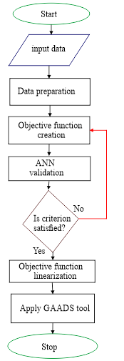

Figure 4- A model resolution flowchart for the study

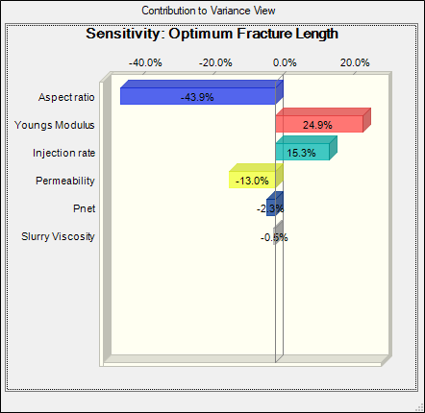

Figure 5- Sensitivity of parameter to the optimum fracture length

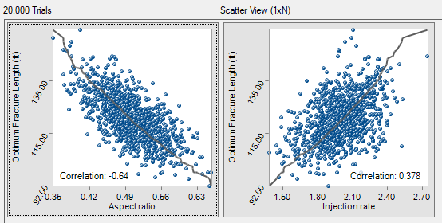

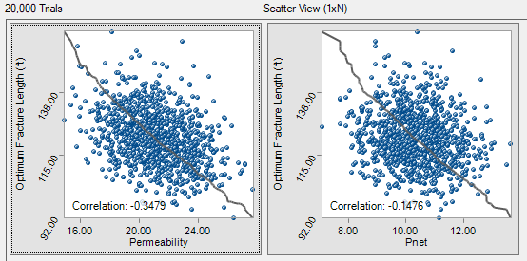

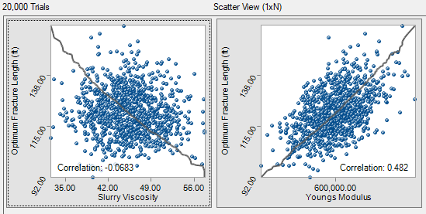

Figure 6- Scatter chart of the forecast-input parameter for fracture length

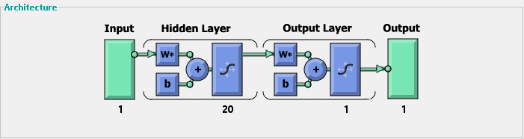

Figure 7- the ANN Architecture for Training the Objective Function

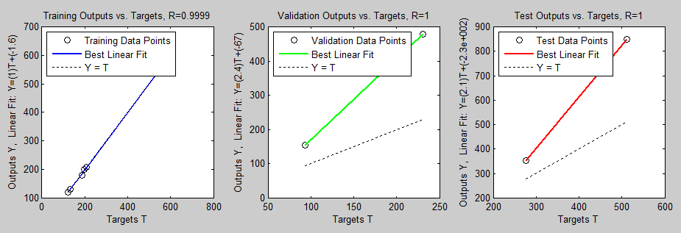

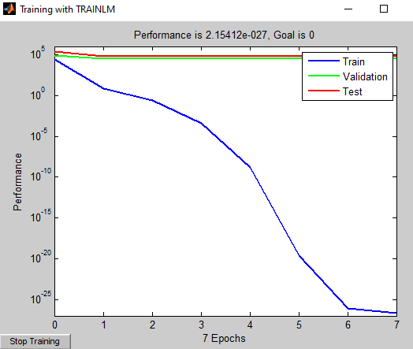

Figure 8- ANN training of the objective function with the HF simulator results



Figure 9: Initial results derived from the GAADS tool



Figure 10: Results from the GAAD tool



Figure 11- GA optimization of the Rastrigin`s function



Figure 12- The generation data of the function value and variables of the new algorithm

**APPENDAGE A- MFile_GA_RUN**

The MFile codes for running the tool

function [X, FVAL, REASON, OUTPUT, POPULATION, SCORES] = MFile for GA run

% This is an auto-generated M file to do optimization with

% Genetic Algorithm and Direct Search Toolbox.

[X, FVAL, REASON, OUTPUT, POPULATION, SCORES] = ga(fitness function, nvars, Aineq,

f=simple_fitness (x);

f = 384.28*(x(:, 1).^0.323)*(x(:, 2).^-0.218)*(x(:, 3).^-0.059)

funcion [c, ceq]= simple_constraint

c=[x(:,1)+x(:,2)+x(:,3)-500; (x(:,1).^0.323)*(x(:,2)^-0.218)*(x(:,3)^-0.059)];

ceq = []